**DESIGN PROJECT REPORTS OF**

**Simulated Life**

Powerpuff Girls

Zhang Qinna

Yin Junhui

Liao Baige

Shen Wangqi

Zhou Chengmao

2020.1.3

*Abstract*

It is reported that China has entered a period of frequent safety accidents in primary and secondary schools, with an average of one class of students disappearing every day due to various safety problems.This data is shocking. Therefor it is important to improve the safety education for primary school students. We design this game named Simulated Life,which is an application for students in primary school to learn how to face the phenomenon that may occur in their daily life.In this game,we have set several stages,such as in the home,in the school and on the way to school. They are the scenes of the daily life of primary school students,which can help students learn the safety knowledge in daily life.

**Contents**

1.0 Introduction 1

2.0 Customer Needs Assessment 2

2.1 Initial Customer Needs List Obtained from Interviews and Observations 2

2.2 Hierarchal Customer Needs List 3

3.0 Revised Needs Statement and Target Specifications 4

4.0 External Search 5

4.1 Benchmarking 5

4.2 Applicable Constraints 5

5.0 The KIEBIE analysis of you learning platform 7

5.1 Environment 7

5.2 Knowledge,Skills,Attitude 7

5.2.1 Knowledge 7

5.2.2 Skills 8

5.2.3 Attitude 8

5.3 Behavior and mental process&status 8

5.4 Interaction 8

5.4.1 Between the teacher and learners 8

5.4.2 The learning scenario 9

5.4.3 The learners' communication in the platform 9

5.5 Experience 10

5.6 Interact Object 10

5.6.1 Human-human interaction 10

5.6.2 Human-machine interaction 10

6.0 Learning Theory 11

7.0 Technology Applying 13

7.1 How does it work? 13

7.2 How is it manufactured and assembled, and what does it cost? 13

7.3 Design validation through test results and operating experience 13

8.0 Learning Analytic 15

8.1 Data 15

8.2 The data capture 15

8.3 The data structure 15

9.0 UX evaluation 17

10.0 Final Design 19

10.1 Registration and login 19

10.2 Homepage 19

10.3 Discussion 19

10.4 Serect book 21

10.5 Ranking 21

10.6 Home 22

10.7 School 23

10.8 Way to school 25

11.0 Conclusions 27

References 28

Appendix:Personal assessment 29

# 1.0 Introduction

Educational games are electronic games with game characteristics and educational functions. By creating virtual situations, educational games arouse learners' curiosity, stimulate learners' fantasy and motivate learners to explore.(魏婷 & 李艺, 2009) Educational games, as the product of the combination of education and games, carry people's good wishes for education and infinite expectations for games, but how to deal with the relationship between education and games in educational games has always been a hot topic for researchers in this field.(丁海东 & 韩云龙, 2007) Educational game design is the key to realize the balance between educational and playfulness of educational games.

With the continuous development of computers, children are exposed to more and more information technology. (程君青 & 朱晓菊, 2007)The influence of games on children is also growing. How to make games promote students' learning to the greatest extent is the attempt of education experts. Some education experts have realized that instead of treating video games as a monster, they should be properly guided to integrate educational elements into the game and bring out the positive meaning of video games.

The main purpose of this course is to design and develop a platform to help students with safety education based on the integration of education and games. On this platform, students can freely choose which safety education content they want to learn, and they can enter the game for situational learning. In this way, students can grasp the teaching content more quickly.

In the design of the game platform, we inevitably encountered a series of difficulties. The first problem was how the storyline progressed. We considered about six or seven scenes, and how to choose the most suitable scene for children was the first problem we encountered. The second problem is what software we choose to develop.

We finally chose to use Axure for the development of the game. We referred to the pokemon game and used the pixelated game style. We designed a 2D game with an overhead view as the first point of view, in which we added different components, such as characters, flames, towels, pools, etc. When we go to the specified game process, the screen will display a dialog box to remind you whether your operation is correct, so as to determine the progress of the game.

**1.1 Initial Needs Statement**

Our team started design platform's point of view is hope to introduce to children about the knowledge of the safety education, so our preliminary requirements is to have a more complete web site, web site has a complete knowledge of the navigation bar to help us to choice, and to build a be able to learn safety knowledge of the game, in the situations for the game to build scene and set up relative to trigger.

# 2.0 Customer Needs Assessment

There is a connection between people's main needs and interpersonal motivation. The research and analysis of the relationship between the two can help to explain the game preference and cultural differences in the game, and promote game workers to design more excellent user-centered games, especially in order to achieve successful game design across cultural boundaries.(章力, 2015) Games have different USES for support and social needs and motivations. Developers must consider this when designing games for different groups. For example, the meaning of in-game fantasy and whether or not internal and external fantasy preferences change across cultures are uncharted territory. As fan suggests, future research may go beyond that, for example, to see that fantasy is constrained by players' expectations of society as well as their reality. By focusing on the definition of the game and how players approach it, we can see how games attract players and promote mutual recognition. In addition, the study of players' self-stated game goals will highlight differences in preferences for a fixed goal in the game. Thus, in a game without a clear goal, there is a clear overall goal or event.



Figure 1 Human factors related to game motivation

## 2.1 Initial Customer Needs List Obtained from Interviews and Observations

This project is an application platform. We had some arguments about whether to choose mobile or computer. At the beginning, we boys thought it was more appropriate to make a mobile terminal, because the development of information technology is getting faster and faster now, everyone has a personal mobile phone, so we can make a mobile terminal to study anytime and anywhere. However, the girl raised some questions. The users we are targeting are young children, who generally do not have personal mobile phones. We designed games on the computer side, so that children can play games under the supervision of parents and parents can give them some guidance.

We interviewed some groups with reference to table 1 and interviewed them about our platform. They asked the following questions about our platform:(1) In our game platform for children, whether for each step to give the appropriate message to help children grasp the content of the professor what we need .(2)In our scenario, for items are not in our design, we have to click on the word should have corresponding reaction (3) after the end of the game, we should design a special module for carding and review, the knowledge we want children to master the knowledge in the game for a summary, so that children can be repeated after the game for a review to drink thinking knowledge.

We self-checked our platform against the dimensions in the table. Our platform is very convenient, we can use the computer for learning, and our platform game USES 2D for modeling and construction, which is easy to load, so we don't need to wait too long to enter the game. The operation of this interface is also very flexible, through the mouse to control the direction of the character, and according to the established game flow to learn relevant safety knowledge. Since we only set up a visual game, we did not need to update and iterate the code in the later maintenance. We only need to update and change the logical connection diagram in the game to make our game look new and achieve the requirements we expected.

## 2.2 Hierarchal Customer Needs List

User interface is an intermediary between man and computer. The user through a user interface to exchange information with the computer. As a result, the quality of the user interface, is directly related to the performance of the application system can give full play to, whether the user accurate, efficient, easy and work happily. So software friendly, ease of use is vital for the software system(白文涛 & 刘正捷, 2004) Factors to consider include interface elements, user roles, requirements changes, and interface prototypes.

For each level of weight, we put customer convenience and usefulness to the game first. First of all, whether a game can be favored by users lies in whether it can be simple operation to bring users happiness or what they need (such as knowledge, ability, etc.).Therefore, our design of the game interface is simple and clear. We also add many prompt boxes containing the security knowledge we want to teach in the game to increase the convenience of the game. Not only did we have a fix for ease of use, we also added a whole story line to the game so users could learn more about security.

# 3.0 Revised Needs Statement and Target Specifications

Through the collection and analysis of the existing problems in the safety education of primary and secondary schools in China, it is found that the problems mainly exist in the following aspects: 1) the low professional quality of teachers affects the actual teaching effect.This problem because usually carry out safety education teachers are part-time teachers, they are not specifically professor safety education course, are the main teacher, so they tend to be in the physical and mental development of the safety education of primary and middle school students don't know, adopted by the teaching contents and methods are not suitable for the students' mental and physical health and lead to the learning effect is not high);2) boring courses fail to arouse learners' interest in learning (at present, most of the teaching methods of safety education are mainly lecture-based, which cannot stimulate learners' interest in learning);3) the number and practical effect of safety education are greatly limited (due to the actual situation, schools often do not construct safety education as a separate course, resulting in short frequency and class period of courses, and learners cannot form a knowledge system);4) Vygotsky (1978), the game contains the learners in the form of a concentrated all the growth trend, and developing children mainly through games, but now although there are many research focus on the safety education based on the technology of VR and somatosensory system and software, etc., but its use is often not a system, did not promote the integrity of the school safety education course construction and development of colleagues lack of practical research on the effect of the system.

Therefore, our design goal is to focus on how to design a game-based safety education platform to support systematic safety education teaching in school curriculum.In order to achieve this goal, the target specification of our platform will be defined from the following four aspects: 1) games can stimulate learners' enthusiasm in safety education;2) the degree to which the platform meets the cognitive stage and learning mode of age-appropriate learners;3) the degree to which the platform supports the learning of systematic safety education knowledge;4) learners' mastery of knowledge through the platform.

# 4.0 External Search

## 4.1 Benchmarking

We want to design the platform to conduct teaching in the form of games, in which the mode of games refers to the two popular games of Pokemon and Fate/stay night: learners control their roles from the perspective of 2.5d, and choose safe education games to play on the platform.Whether in the process of game selection or in the process of game play, interaction is conducted in the form similar to galgame, that is, users click to trigger the corresponding, promote the story development through user options, and set different game routes and endings to supplement children's safety knowledge map.

Therefore, we choose Pokemon, Fate/stay night and domestic safety education platform APP as our system benchmarks.

Table 1 Benchmarking of Products

|  |  |  |  |
| --- | --- | --- | --- |
| **Feature** | **Pokémon** | **Fate/stay night** | **Safety education platform** |
| Games can stimulate learners' enthusiasm in safety education | The drawing style of Pokemon is extremely in line with children's aesthetic standards, and the rich colors and interactions in the game can stimulate learners' interest in learning. | By setting different story lines, learners are guided to play games. With the deepening of the game process, their curiosity is constantly stimulated. | The platform provides rich news and tweets related to safety education to enrich the content (but not the systematic course content). |
| Platform meets the cognitive stage and learning mode of age-appropriate learners | The easy and convenient operation of Pokemon is very convenient for children to explore, and the integration of children's playing process and learning process can leave a deeper impression. | During the game, children can interact with the surrounding environment under the time limit and make the right or wrong behavior choices, which is consistent with the decision-making process of children in the real process. | Most of the content in the platform is similar to the push of WeChat public account, which is presented in the form of plain text and pictures. Although it involves a lot of content, it does not conform to the learning rules of children. |
| Platform supports the learning of systematic safety education knowledge | The game has external scenes and internal scenes. The external scenes are used for level selection, while the internal scenes are used for safety education, which can systematically integrate the safety knowledge in various situations and promote the systematic learning of knowledge. | Children clicking on different interactive objects in the scene or making different decisions will trigger different influences, which will lead to different results, which will be displayed in the knowledge map of learners. | The presentation form of platform content is relatively scattered, and it is not organized according to the logic of course teaching content. But basically cover the general knowledge. |
| Learners' mastery of knowledge through the platform | There is a user information collection and processing function similar to the "backpack" function in the game, which can record learners' learning trajectory and related knowledge points in the process of the game and help learners construct knowledge map for learners to watch at any time. | Encourage learners to learn in a certain scene for many times to trigger different events or to become proficient in an escape process, which can be reflected in the knowledge map of learners, and at the same time ensure the breadth and proficiency of learners in the safety knowledge of corresponding scenes. | The fragmented teaching content can not ensure the learning effect of learners.It is necessary to design the learner's learning process.Since the platform APP cannot record the learning process of learners, how to collect and analyze the behavioral data of learners has become one of the key points in our game design. |

## 4.2 Applicable Constraints

Within our group, the biggest limiting factor is experience.We in the platform development and game development has a certain experience, but when it comes to study in specific content or platform development, curriculum content, we for the lack of knowledge structure and course contents for lack of learners learning process knowledge is gradually revealed, the learners' learning process and become restrict our platform, making the teaching characteristics and cognitive style.

For external, first of all, our platform is a limiting factor for the market, because although the lack of a complete safety education system and the associated platform tools school a lot, but because most schools are still set on students' safety education as the extensibility of learning knowledge, and not into the corresponding energy to mining course, hire teachers, etc.Secondly, there is a lack of corresponding curriculum system for safety education in China, which makes us only involve comprehensive knowledge as much as possible when developing the platform, and construct the knowledge map of learners by ourselves, which may not meet learners' demand for safety education knowledge.

# 5.0 The KIEBIE analysis of you learning platform

## 5.1 Environment

Since our group plans to build a safety education platform for primary and middle school students, the main environmental atmosphere is the network environment in the early stage and the real life situation after the end of learning in the later stage.Students can further experience and practice in real life through the interaction with platforms, experts and themselves, so as to have an impact on their own safety awareness and safety behavior, and further acquire relevant safety knowledge.And knowledge can also interact with each other when it is applied to our real life and directly affects our learning behavior.Then Student actively construct or create their own subjective representations of objective reality.

The final design of our group's project is an APP about "safety education". The main operating environment is mobile devices, and the main internal platform is 2D+ 2.5D context setting.Because we want to present the main content of this project is about safety knowledge, through the popularization to give students knowledge about safety, further with the help of a real disaster situation, help students immersed in a learning platform, and presented to students in the form of the game, let the students learn in the game, play in learning.

## 5.2 Knowledge,Skills,Attitude

### 5.2.1 Knowledge

Students will learn a lot about safety,there are mainly the following aspects:

Health and hygiene: sex, drugs, allergies, infectious diseases, influenza, hepatitis, gastrointestinal tract, drinking, smoking, healthy weight loss, food safety, common sense, eye protection, etc.

Network security: radiation, network security, network crime, network morality, network resources, Internet cafes, Internet addiction, online games, online shopping, online love and so on.

Mental health: teacher-student relationship, classmate relationship, adolescence, puppy love, secret love, star worship, rumors, civilized language, learning attitude, weariness of learning, psychological adjustment, impulse, vent, fear, hypocrisy, depression, selfishness, family communication,

Natural disasters: rainstorm, hail, red tide, air pollution, earthquake, drought, high temperature, tsunami, flood, landslide, volcano, wind, thunder and lightning, mudslide, dense fog, forest fire, sandstorm, acid rain, haze, snow disaster, warning signal.

Accidental injuries: explosion, trampling, electric shock, knife use, elevator, radioactive pollution, animal injury, chemistry, nosebleeds, gas, drowning, lab safety, burns, fire protection, fireworks, choking, insurance, electricity, sports, asphyxiation, etc.

Other security: kidnapping, privacy, property, integrity, legal knowledge, cults, stalking, national security, traffic, terrorism, ethnic culture, robbery, extortion, personal safety, theft, sudden accident, marketing, false accusation, school violence, sexual assault, lost, fraud, etc.

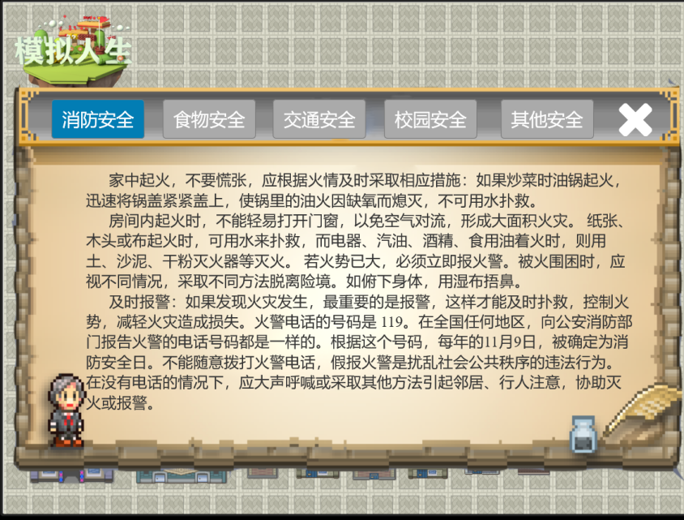

Figure 2 The secret book

### 5.2.2 Skills

Through the establishment of scenarios, learners can learn how to act and deal with potential dangers in some situations.

### 5.2.3 Attitude

After leaning the knowledge about safety,students will be more in awe of and grateful for the nature, the awareness of environmental protection has been improved, and they will pay more attention to early warning signals, etc.It will also improve the life safety awareness of learners,pay more attention to health,and they can put adolescent emotional problems in perspective.

## 5.3 Behavior and mental process&status

In the study of safety education platform, students' learning behavior is mainly reflected in the following aspects:

Interaction between students and the platform. Through learning on the platform, on the one hand, students can enhance their safety awareness and on the other hand, improve their self-protection ability.

Transformation and adaptation of knowledge. Students learn relevant safety knowledge through the platform and will transform it into some means to protect themselves according to their actual situation.

## 5.4 Interaction

### 5.4.1 Between the teacher and learners

Our app support using for different roles,and different roles can manage the students’ length of using time and when to use.The teacher will also see the students’ learning process,and have a teaching feedback.

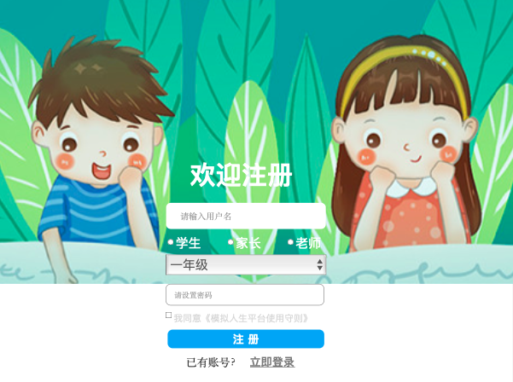

Figure 3 The Registration

### 5.4.2 The learning scenario

When enter the APP,students can choose the learning (game) scenario according to their preferences,and in different scenarios they will experience different safety problems.Finally,they will also learn different knowledge about protect themselves.

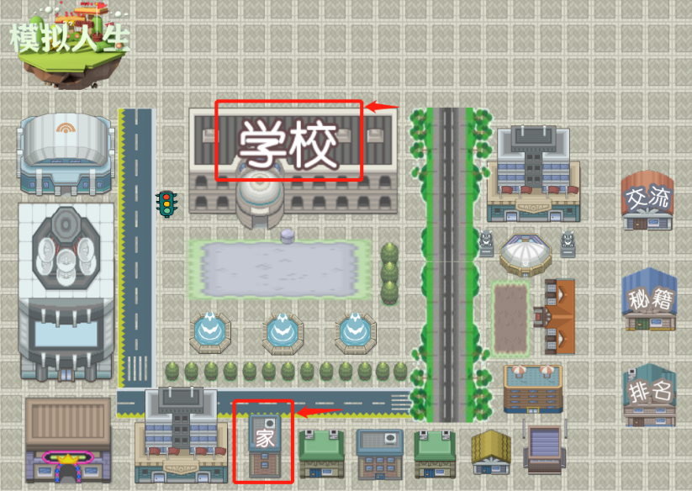

Figure 4 The homepage

### 5.4.3 The learners' communication in the platform

Students can talk with each other when they come cross problems,and they can also ask the administrator for help.They can choose the type of safety questions,then to ask questions.

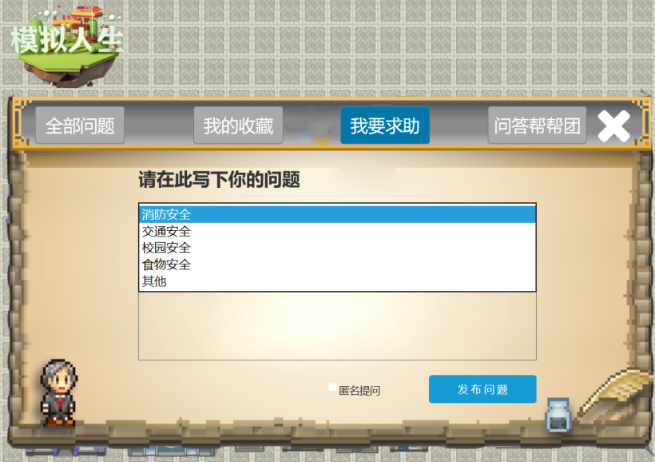

Figure 5 The interface of *Ask for help*

## 5.5 Experience

The safety is quietly important to the young children. So we can use this platform to enhance the awareness of safety. Our project think it is very easy to use this platform.Firstly you need to sign up an account(the parents and teachers can help the children do this thing),and there will be a lot of columns that about different types of the safety after logging in.Secondly, you can choose a column you want the children to learn and a Flash will appear after clicking the button. What will display on the screen is that there is a girl will face to some dangerous (we have designed some stories) and the platform will give two choices that the children need to choose. And the outcome will be different depend on what the children have chosen. If they chose a wrong one, the platform will display the bad consequence-the girl got into troubles and tell them how to deal with this problems, but if they chose the right one, they will facilitate the girl to achieve her goals.

The platform aim to help children construct the knowledge by the virtual reality. Let them react to the situation to build a right framework about safety.

## 5.6 Interact Object

### 5.6.1 Human-human interaction

（1） Students-students

Students can communicate online and offline after playing the game.In addition, because this APP is a tutor teaching tool for teachers, students can also exchange and discuss relevant games and safety knowledge in the course discussion section of the classroom.

（2） Students-teachers

Teachers can log on the platform to check students' learning progress and students' communication status, and know more about students' learning status, which can further help teachers to give feedback on teaching.

（3） Student-parents

Parents can log on to the platform and check the students' learning status.Parents can also control how much and when students study.

### 5.6.2 Human-machine interaction

Students can manipulate the arrows on the screen to move, play games, and interact with the machine.

# 6.0 Learning Theory

Constructivism teaching method organizes teaching according to the steps of "understanding the task -- knowledge review -- doing middle school -- self-reflection -- teachers' summary and improvement -- new task verification". The learning method advocated is student-centered learning under the guidance of teachers.The constructivist learning environment contains four elements: situation, collaboration, conversation and meaning construction（何珊，2019）.Constructivism has been regarded as an effective learning theory in which learners construct mental representations by participating in appropriate positive cognitive processing（钟丽佳，盛群力，2016）.Others try to see it as a teaching prescription, believing that learners can have positive learning behaviors.It would be inappropriate to assume that active cognitive learning derives from hands-on activities such as discovery learning, or that passive teaching methods such as multimedia presentation fail to motivate active cognitive learning（郑霞，2014）.

Cooperation and conversation occur throughout the learning process, whose function is to make the wisdom of each learner Shared by the whole learning group, to realize more resource sharing and maximize the use of resources（高奇琦，2014）.At present, the application of team learning in the teaching of undergraduate course phase is not mature and perfect, as the need of creative thinking and comprehensive simulation training of team communication coordination, if we can scientific manage the learning process and answer session, will be working ability of students to acquire the future play a positive role.Meaning construction refers to a deeper understanding of the nature of things and the internal relations between things.Let students have a more comprehensive understanding of the inner relation and law between things（Willem,2020）.Through the long-term improvement of learning methods, to have the optimization of learning methods.In fact, it requires students to consciously train their way of thinking in daily learning, which is also the internalization of one's learning habits(Hannah etl,2019).With the development of network and information technology，the network-based multimedia teaching platform will play an increasingly important role.With the guidance of constructivism,an open autonomous and convenient-to-communicate platform for network teaching has been successfully designed and put into teaching practice,achieving ideal teaching effects and realizing teaching-learning transaction．

Therefore,as for our app”The SIMS”,the main learning theory we use is Constructivism.

The constructivist learning theory emphasizes that students are the center, and the learning environment elements such as situation, cooperation and conversation should be used to give full play to students' initiative, enthusiasm and creative spirit, so as to effectively realize the purpose of constructing the meaning of current knowledge."Situation", "collaboration", "conversation" and "meaning construction" are the four elements in the constructivist learning environment.Media is no longer a means and method to help teachers impart knowledge, but a cognitive tool to create situations, conduct collaborative learning and conversational communication, that is, to serve as students' active learning and collaborative exploration.

First of all, on the platform in use process, can be on the current through collaboration between need students learning for further inspection.Secondly teachers apply it in the teaching, produce certain teaching knowledge, help students to learn.Finally, online management for students to solve the problem of students in the process of use.

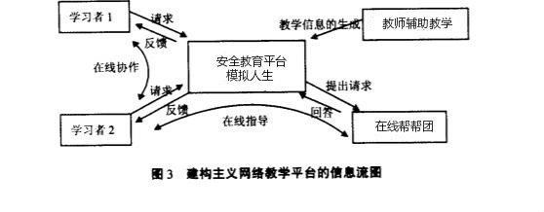

Figure 6 The flow chart of information

# 7.0 Technology Applying

## 7.1 How does it work?

Enter the platform, register and login, three login modes, teachers, parents and students, currently only the student mode, the follow-up will improve the teacher mode and parent mode.

In the student mode.When students enter the platform, there is a map of the city, as well as a discussion board and the start button of the secret book.There are various safety trigger scenarios on the map, however, the game's protagonist needs to start from the start scene and proceed from the scene to the scene.The trigger scenes are like a tree, one after another, with different life stories.

Here, each scene is a web page, the user selected or clearance, page automatically jump.Enter the level, that is, for the security scene, the user needs to make the correct operation in the corresponding scene, take the first scene to see.The first safety scene is the fire scene, the fire occurred in a child's home, the child's home on the 88th floor, and the child at home alone.The hallway in front of the door is also full of smoke, children should be any operation.Here, the smoke leading to the hallway in front of the door is an interactive object. If the child does not get a wet towel, he will not be able to get through the door.Out of the smoke, and the window, refrigerators and other interactive object, would give the user the corresponding to ascend, one of the most important is the leading role of the scene, fire, fire control, by the time every few seconds, the flame will rise in a row, when children close to the flame, the screen will warn dangerous words suggest children, used here is that the scope of monitoring function, when the child object and the scope of the flame wants to contact, trigger this warning.Children correct operation is, first to dry handkerchief next to pick up the handkerchief, then go to the pool next to the handkerchief wet, and then out of the house.During this period, the scope monitoring function is used to judge whether the children are close to the object to be picked up or the object to be operated, and then interactive operation is conducted through button monitoring.In the process of operation, the knowledge text dialog box will appear to guide the learner.

Of course, children is easy to control, it is by clicking on the detection, if the button is clicked, the up and down or so one direction is to carry on the corresponding movement, in the process of mobile need to constantly change the role of the state, in this platform, the state of one direction can be divided into the four, then transform a moving forward, such as 100 milliseconds after the next state change, and then move, such repeated cycle.

## 7.2 How is it manufactured and assembled, and what does it cost?

Table 2 The materis

|  |  |  |  |  |
| --- | --- | --- | --- | --- |
| NO. | Part | Qty | Description | Cost |
| 1 | screen size |  | 889*1254(unit: pixel) | Free |
| 2 | Deploy the site |  | Early user is not much, in order to reduce the cost with the student server | Free |

## 7.3 Design validation through test results and operating experience

I need to know whether the user leaves halfway through the process.Because of the timing function, record the learners in the process of customs clearance in time, so, to see whether the user has been in operation state is very important, if the user had to a certain level of knowledge is very familiar with, but he is in the process of recruit to do other things, delay the recruit, increased the customs clearance time, make the system error to learners for the knowledge point here is not familiar with.

In my opinion, based on the above problems alone, a video monitoring test instrument is needed to test the user's breakthrough state, so as to judge whether the feedback of learners' learning effect is accurate.

Test the video monitoring results of multiple users and the judgment results of the system learning effect, compare a number of results, calculate whether there is a significant difference between the two, so as to test whether the system learning effect judgment here is feasible.

If there is no significant difference between the result of video monitoring and the judgment of system learning effect, it indicates that the platform's learning effect evaluation is reasonable and can be applied to practical operation.

# 8.0 Learning Analytic

## 8.1 Data

The required data include: the time spent on each page by the user, the order and number of button clicks by the user.There are also discussion forum text data, secret book library secret book view and collection times.

The safety awareness of learners affects the learning experience of learners, that is, the ability of users to make a pass in the game context.

This needs to be supported by data from other levels, including: by time, by class ranking of time, by operational accuracy in the process, etc.User clearance time data can affect the level richness in future design;

The accuracy of the clearance operation can affect the difficulty of the level in the future design.The secrets and data in the discussion boards can influence the themes that levels focus on in future designs.The data collected so far is the time spent on each page, the order and number of button clicks.There are also discussion forum text data, secret book library secret book view and collection times.Because I need and still need to use these data to analyze learners, so that they can be fed back to us and teachers for targeted content push.

## 8.2 The data capture

We'll keep track of the text data in the discussion area directly in the form of xapi, because our discussion area data is messy;

Other data will be obtained from existing applications and then converted into xapi format, because the structure of passing time and clearance click operation data in the game is relatively uniform, it is easy to collect in the game, and the collected data will be converted into xapi format, which is easy to operate.

## 8.3 The data structure

There are three types of actors: teacher, parent, and student.

There are three roles that need to be labeled differently in the software.

The platform is mainly used by students, in which students will generate data such as passing time and passing operations.

The teacher can get a student through data, and the teacher will have the function of directly click through, in customs clearance convenient teachers understand the level and knowledge, and teachers with the knowledge and students' data, to analyze the students' learning situation, the analysis can be used to promote the teacher teaching and student learning, moreover can also sent to the parents.

Parents have access to the analysis sent by the teacher and to the learning data of their children, the overall class data.

Verb: automatically select the platform language by IP, and of course, there will be a Settings window at the Settings.

The game interface is available in both Chinese and English, but the discussion in the discussion board is in the original language. Users need to solve this problem by themselves. Of course, if the cost allows, we will embed the translation function.

Object: in the process of the game, the learner will be faced with many objects in the scene, and the user needs to finish the game correctly and click the objects in a certain order. This is the data I need -- the order in which the user clicks.

What's more, during the whole activity, the user always cleared the customs at the time.

Result: here, the Result of user data can be the focus of the instructor's teaching.

How does the data here tell us what needs to be taught more?

The accuracy, clearance time, text data in the discussion area, and the observation and collection data of secret books need to be summarized as a whole. The lower the accuracy, the longer the clearance time, the more frequent the occurrence of keywords in the discussion area, and the greater the click volume of secret books, the content that needs to be taught is the most important.

Context: the study of the content in the process of the game, the learners immersed in the game can learn related knowledge, the relationship between the gate and gate is like knowledge and the relationship between the knowledge points, each level of knowledge is not exactly the same, but some content have similarities, students can according to the existing knowledge to try some levels is how to recruit.

Thus, learners are encouraged to acquire relevant knowledge.

Authority: data only plays a role in assisting teachers in teaching. The design characteristics of this platform should also be seen from the special learning content. As it is a platform for safety education, students do not have much time to learn in school.

And the software also follow this rule, but the platform is make learners study by means of the game, and the resulting data supply analysis of the teacher, the teacher to know what types of security knowledge is bad students master, the need to explain what safety knowledge, then similar to flip the way of the classroom, the teacher can on campus, to focus on the knowledge of interpretation, the authority here is the data and the teacher.

Timestamp: no need, data form is simple, operation is statistics, and then stored, so that teachers can analyze students' learning situation in real time.

Attachments: Attachments can be uploaded by teachers and students in the discussion forum, so that knowledge can be expanded and students can learn more than the original content.

# 9.0 UX evaluation

Our project mainly adopts the method of questionnaire survey to survey the users who have used our platform, and a total of 10 questionnaires have been collected.According to the statistics, there are four majors: education technology, management, computer science and economics.

After analyzing the data, the following results are obtained：

Table 3 Skale means per person

|  |  |  |  |  |  |  |
| --- | --- | --- | --- | --- | --- | --- |
| 纬度 | 吸引力 | 明晰 | 效率 | 可靠性 | 促進 | 新奇 |
| Person 1 | 2.83 | 2.50 | 2.25 | 2.50 | 2.50 | 3.00 |
| Person 2 | 3.00 | 2.50 | 1.75 | 1.50 | 1.25 | 1.50 |
| Person 3 | 2.83 | 1.00 | 2.50 | 3.00 | 3.00 | 2.75 |
| Person 4 | 0.50 | 0.00 | -0.25 | 0.00 | -0.25 | 0.25 |
| Person 5 | 2.17 | 2.25 | 2.75 | 2.50 | 2.00 | 2.25 |
| Person 6 | 1.67 | -1.25 | 1.50 | -0.75 | -0.75 | 0.25 |
| Person 7 | 0.33 | 1.00 | -0.25 | 0.75 | 0.75 | 1.00 |
| Person 8 | 1.33 | 0.00 | 0.50 | 0.25 | 1.00 | 0.00 |
| Person 9 | 2.00 | 1.75 | 1.00 | 1.00 | 1.75 | 1.00 |
| Person 10 | 3.00 | 3.00 | 3.00 | 3.00 | 3.00 | 1.50 |

As can be seen from the figure above, the evaluation of our platform among the respondents

(1) As for the attractiveness of the platform, only two people gave less than 0.5 points, while the other eight people all thought that our platform was attractive to some extent, and two questionnaires scored 3 points, indicating great interest in our platform.

(2) Two zeros appear in the dimension analysis of platform clarity, indicating that two people still have some questions about the clarity of our platform;There is also a negative value, indicating that there is a negative attitude to the clarity of the platform;However, there are also three points, indicating that there is still a big difference in the current users' attitude towards the clarity of our platform. Therefore, this part of our project needs to be strengthened.

(3) In terms of efficiency, there are also two negative values, but others think that our project "SIMS" is efficient, so we can continue to strengthen the platform in terms of ease of use and help learners learn better.

(4) In terms of reliability, the overall score is not high, but there is no particularly low score.That is to say, the stability of our platform is certain to some extent, but there are still some users who think our current platform is not reliable enough, indicating that we can improve our platform.

(5) Through the analysis of the above dimensions, there are still two negative values in combination with the "promotion" dimension. Therefore, our platform is improved in the design, transformation and "discussion" module of "security scenario".

(6) Because the last dimension is not a strict standard for the platform, the knowledge is a reference for two platforms.According to our data, users' experience on the platform is positive, and our platform is innovative for most users' experience.

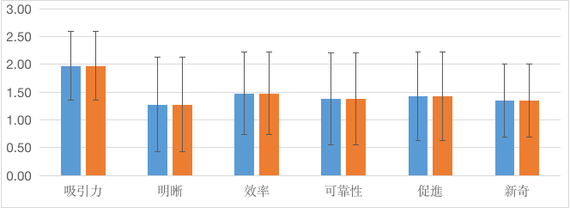

Figure 7 Scale means

Table 4 Comparison of Scale Means

|  |  |  |  |  |  |  |  |  |  |  |  |  |
| --- | --- | --- | --- | --- | --- | --- | --- | --- | --- | --- | --- | --- |
| Scale | Data Set 1 | | | | | | Data Set 2 | | | | | |
| Mean | STD | N | Confidence | Confidence Interval | | Mean | STD | N | Confidence | Confidence Interval | |
| 吸引力 | 1.97 | 1.00 | 10 | 0.62 | 1.35 | 2.59 | 1.97 | 1.00 | 10 | 0.62 | 1.35 | 2.59 |
| 明晰 | 1.28 | 1.37 | 10 | 0.85 | 0.42 | 2.13 | 1.28 | 1.37 | 10 | 0.85 | 0.42 | 2.13 |
| 效率 | 1.48 | 1.19 | 10 | 0.74 | 0.74 | 2.21 | 1.48 | 1.19 | 10 | 0.74 | 0.74 | 2.21 |
| 可靠性 | 1.38 | 1.33 | 10 | 0.83 | 0.55 | 2.20 | 1.38 | 1.33 | 10 | 0.83 | 0.55 | 2.20 |
| 促進 | 1.43 | 1.28 | 10 | 0.79 | 0.63 | 2.22 | 1.43 | 1.28 | 10 | 0.79 | 0.63 | 2.22 |
| 新奇 | 1.35 | 1.06 | 10 | 0.65 | 0.70 | 2.00 | 1.35 | 1.06 | 10 | 0.65 | 0.70 | 2.00 |

According to the statistical analysis of the basic values of the data, the average value of the five dimensions of the platform is between 1 and 2, with the highest score of 1.97 for the attractiveness of the sequential platform and the lowest score of 1.28 for the clarity of the platform.Directly targeted at our platform, namely, the "safety education scene" of the platform has certain innovation, but the interaction in other aspects of the platform should be further improved.To sum up, the clarity of the platform needs to be further strengthened, but the scores of the five dimensions of the platform have certain reference value, indicating that the current usability and effectiveness of our platform have certain reference value.

# 10.0 Final Design

Based on the above thoughts,we have come up with three scenes that are related with students.The details of the final design is listed as follows.

## 10.1 Registration and login

When the user enters the system for the first time, the user is prompted to register with a username and password. At the same time, users will also be asked to fill in identity and grade information. The later system can push personalized message service according to students' grades.

If the user has already registered, then you can hit and click login now, jump to the login interface, and login directly through the user name and password.



Figure 8 The registration Figure 9 The login

## 10.2 Homepage

After logging in, you can enter the main interface of the platform, which is a scene simulating the user's life, as shown in the Figure 9. The top left corner is the logo of the platform, and the middle area is the building shape button that can be clicked. Users can click different buildings to go to different scenes. There are three buttons on the right, which are communication, secrets and ranking. The character in the upper right corner is also a button, which can be clicked to see the user information, as shown in the Figure 10.

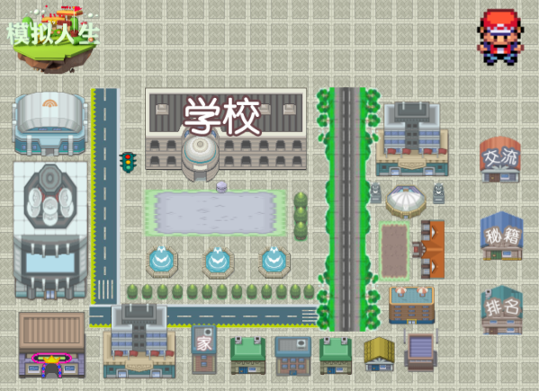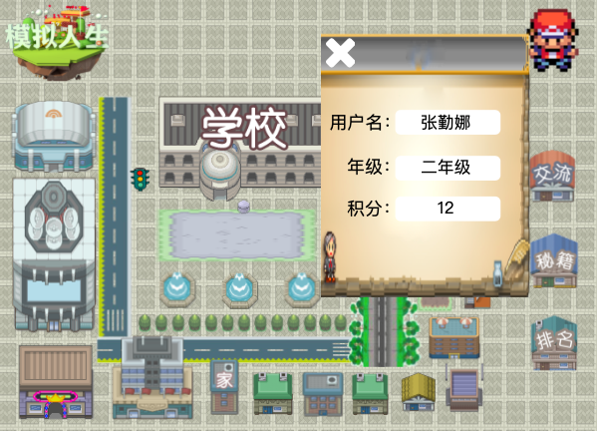

Figure 10 The homepage Figure 11 The individual information

## 10.3 Discussion

When we click the communication button, we can see four sections, which are *all the questions*, *my collections,* *I want to ask for help* and *q&a* helpgroup, as shown in the Figure 11. The module of *All questions* is similar to a forum, the user post reply card will be recorded here. Each post has a love, which can be clicked by mouse, then the post can be collected, appear in my collection plate. The third part is that I want to ask for help. If the user does not find any solutions in all the questions, then the user can ask others for help by Posting. The last section is the q&a helpgroup, where some security education experts are set up. If the user has some unspeakable or particularly difficult questions, then they can click on the avatar of different experts for one-to-one consultation,as shown in the Figure 13,Figure 14 and Figure 15.

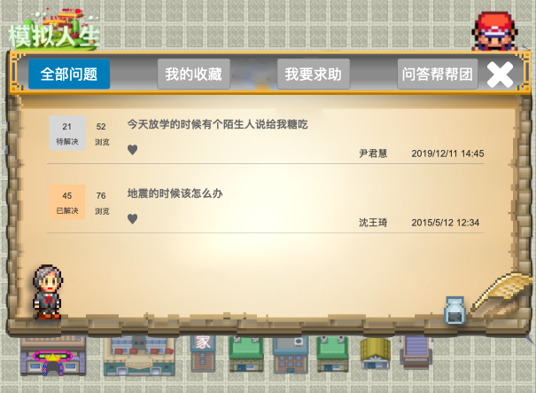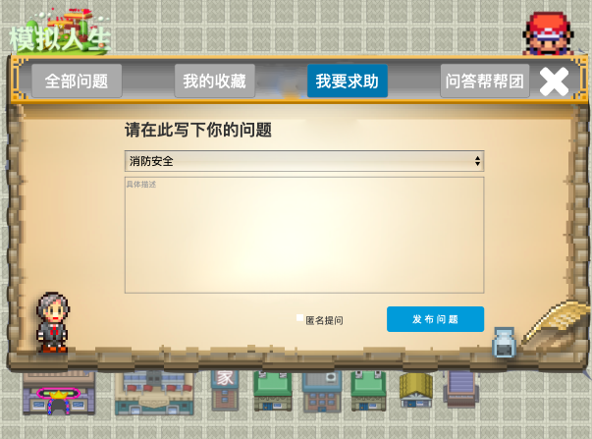

Figure 12 The communication(①) Figure 13 The communication(②)

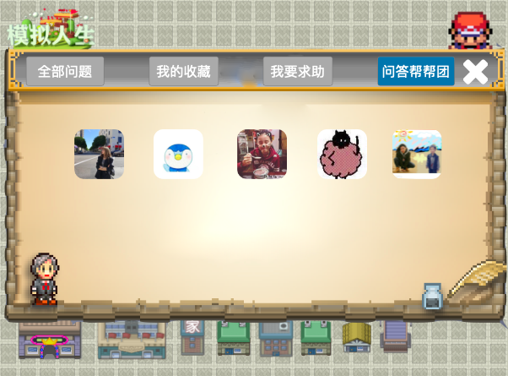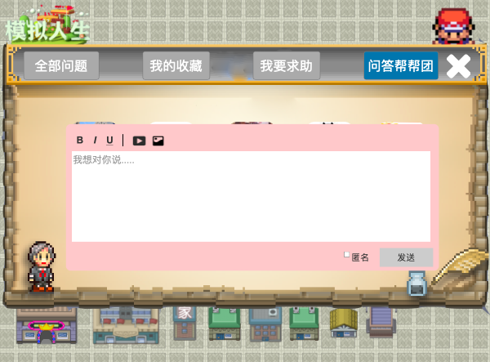

Figure 14 The communication(③) Figure 15 The details of question and answer group

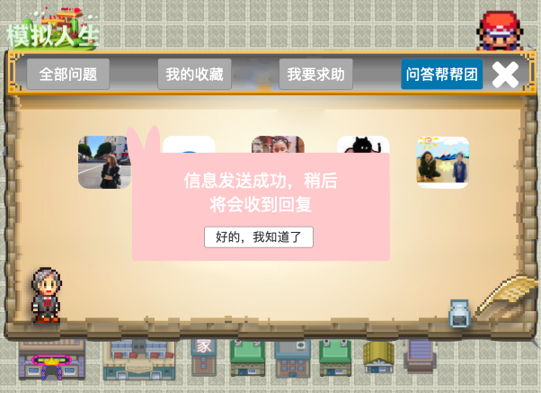

Figure 16 The feedback

## 10.4 Serect book

By clicking the button of serect book,users can open this dialog interface, as shown in the Figure 16.We have divided the secrets into five parts: fire safety, food safety, traffic safety, campus safety and other safety. These safety knowledge is closely related to the daily life of primary school students, which can help primary school students to better apply the knowledge learned in life. The knowledge shown in the secret book can be personalized push according to the user's operation to help the user further deepen the security knowledge ignored in the process of the game.

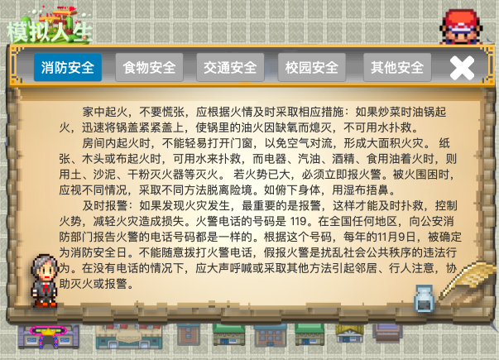

Figure 17 The serect book

## 10.5 Ranking

In the process of playing the game, the system will record user mouse click stream, the number of trial and error, and try to correct the number of times, the information such as time, to give the user the corresponding scores by calculation, in a shorter period of time to complete the customs clearance will get higher scores, compare scores of students within the same class, can stimulate the number of users to try to practice, in order to get higher scores and rankings,which is shown in the Figure 17.

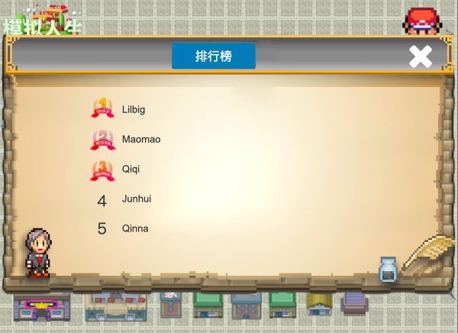

Figure 18 The ranking

## 10.6 Home

In this scenario, we set the situation that the user was alone at home and there was a fire in the home. The user needed to find a handkerchief in the room and wet it with water, cover his mouth and nose and go down the stairs, that is, the user was supposed to master the safety knowledge in this situation. The room is equipped with sofa, bookshelf, window, refrigerator, bed and other furniture, through the mouse click can also get different tips, to help users master more fire safety knowledge.

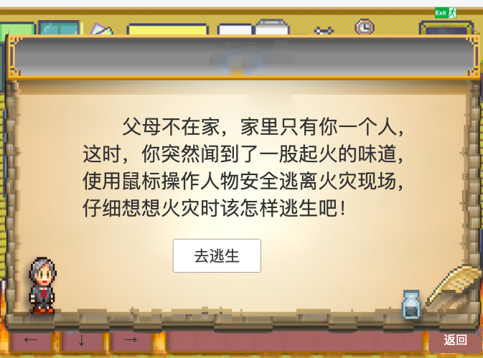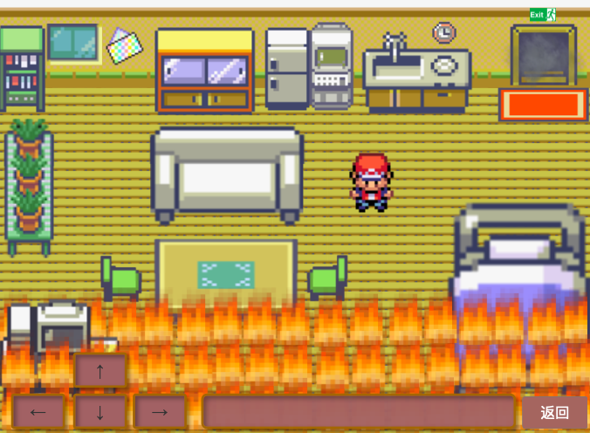

Figure 19 Introducation of home Figure 20 Interface of home

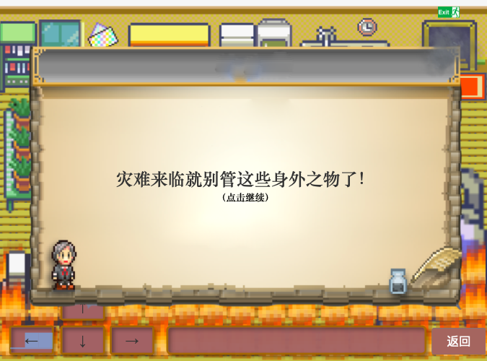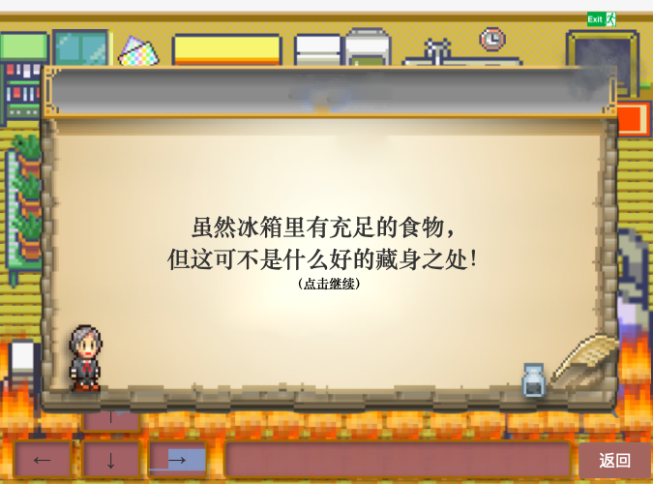

Figure 21 Feedback of bookshelf Figure 22 Feedback of fridge

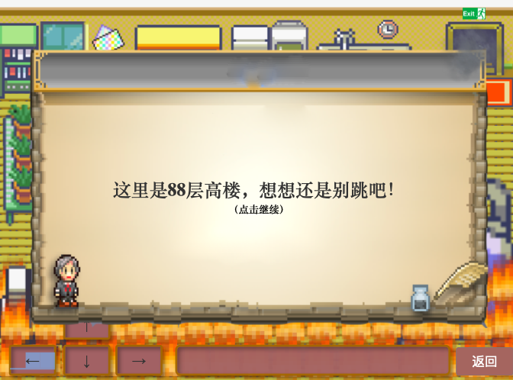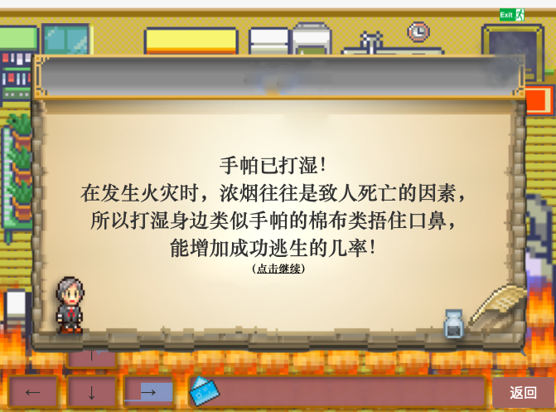

Figure 23 Feedback of windows Figure 24 Feedback of information

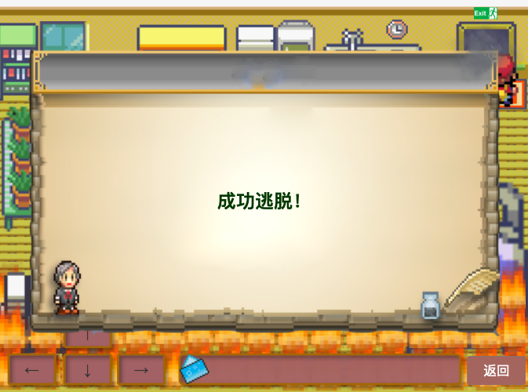

Figure 25 Feedback of succeeding

## 10.7 School

In this scenario, we set up the situation where the user encounters the campus bully in the school to collect protection money. In the face of the evil forces in the campus, what should the children do? We set up different options to jump to different prompt messages according to the user's choice. If the user chooses strong resistance, the prompt shown in Figure 29 will pop up. If the user finally chooses not to tell the parents or teachers, the prompt shown in Figure 30 will pop up, followed by the correct action prompt shown in Figure 31.

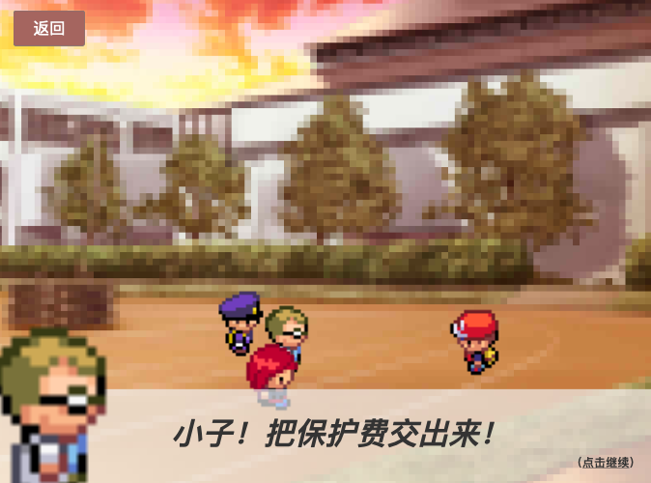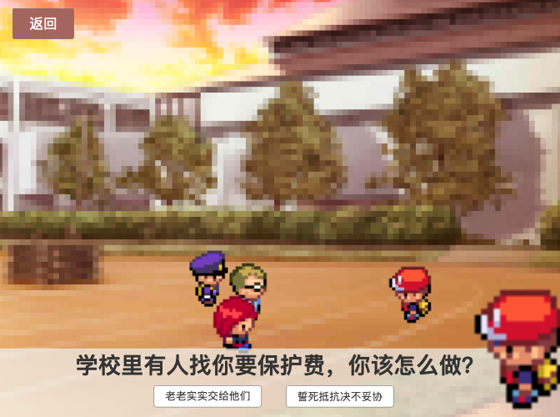

Figure 26 Introducation of school Figure 27 Choice(①)

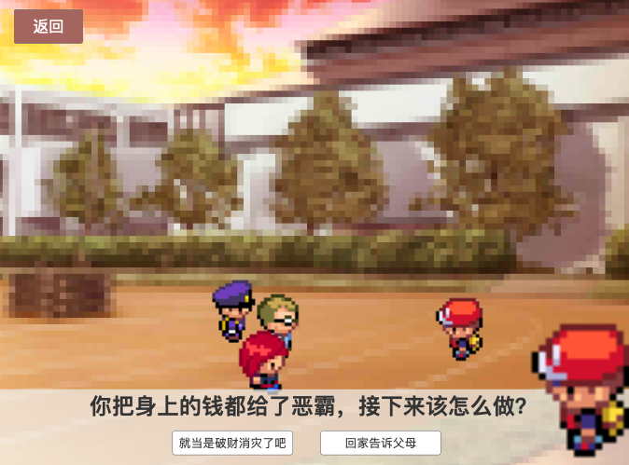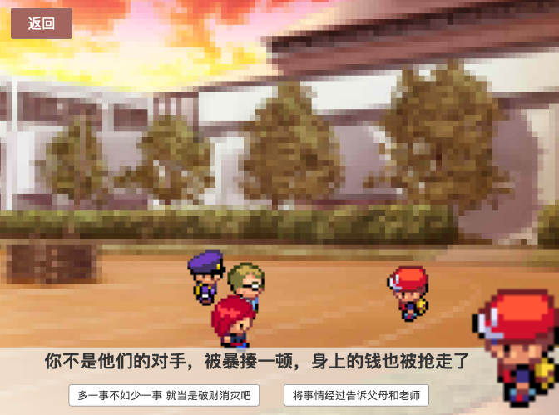

Figure 28 Choice(②) Figure 29 Choice(③)

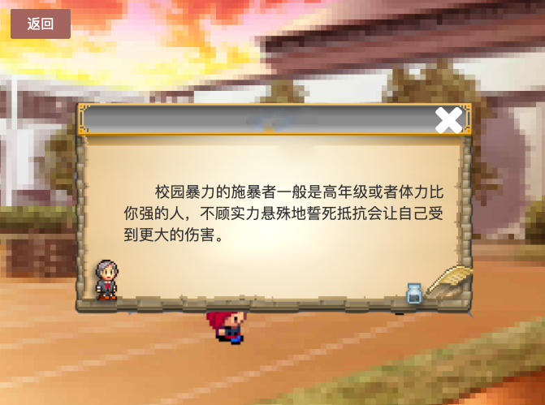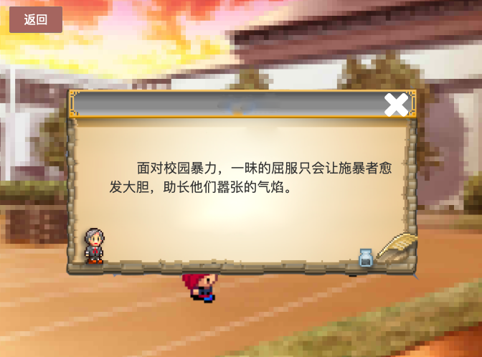Figure 30 Feeback(①) Figure 31 Feedback(②)

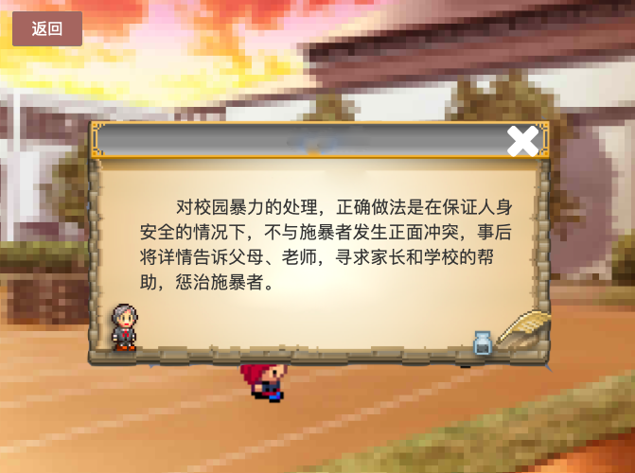

Figure 32 Feedback(③)

## 10.8 Way to school

In this scenario, we set up the user alone from home to school situation, the user needs according to the traffic lights command and vehicle running safety across the street, if the user character and vehicle collision, will jump out as shown in the Figure 34, if the user still to cross the street at a red light, then will jump out of the tip as shown in the Figure 35.

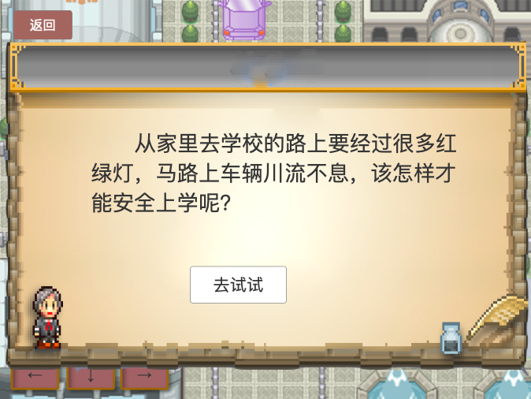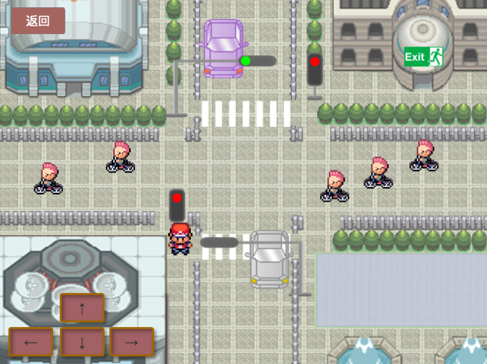

Figure 33 Introduction of way to school Figure 34 Interface

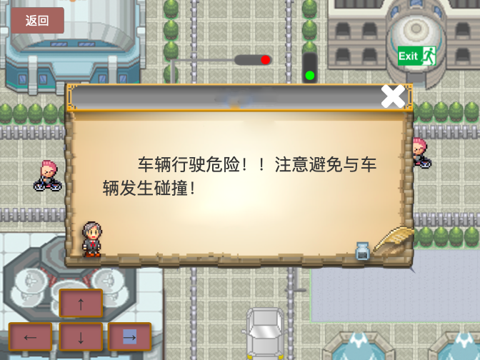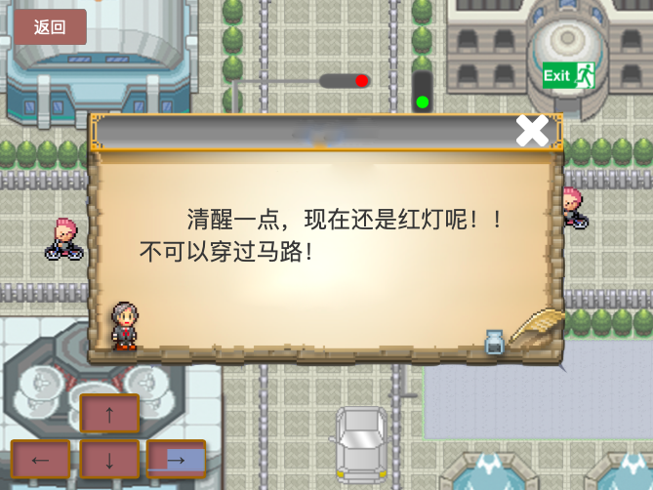

Figure 35 Feedback(①) Figure 36 Feedback(②)

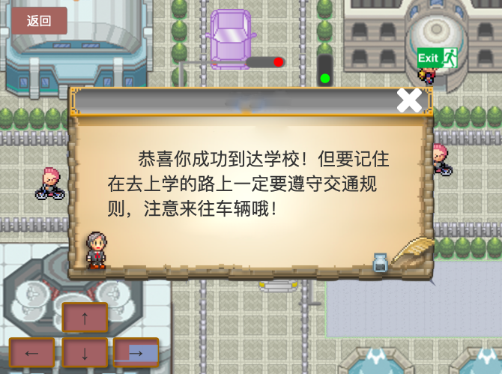

Figure 37 Feedback of succeeding

# 11.0 Conclusions

We can learn from various information channels about the current safety accidents among teenagers, countless, so the safety education of teenagers need to cause us enough attention.Based on the constructivist learning theory, the Simulated Life aims to create an immersive learning experience for users.

We chose fire safety, campus safety and traffic safety three kinds of safety education knowledge to do a detailed game design. In the design process, how to transform the abstract safety education knowledge into the knowledge acceptable to children? We thought about the design of educational games.With the continuous development of computers, children are exposed to more and more information technology. The influence of games on children is also growing. How to make games promote students' learning to the greatest extent is the attempt of education experts.

Therefore, we chose the three scenes of home, school and on the way to school as our main design scenes, because these three scenes are the places where children have the most contact in their daily life, and also the places where safety accidents are easy to happen.

# References

白文涛, & 刘正捷. (2004). 用户界面的需求分析与设计原则. 大连海事大学学报, 30(4), 86-88. doi:10.16411/j.cnki

程君青, & 朱晓菊. (2007). 教育游戏的国内外研究综述. 现代教育技术, 17(7), 72-75.

丁海东, & 韩云龙. (2007). 论游戏与教学的整合. 学前教育研究, 12, 50-52. doi:10.13861/j.cnki.sece.2007.12.017

魏婷, & 李艺. (2009). 国内外教育游戏设计研究综述. Journal of distance education, 3, 67-70. doi:10.15881/j.cnki.cn33-1304/g4.2009.03.013

章力. (2015). 电脑游戏设计中的用户需求和动机分析. 艺术与设计(理论), 2(09), 79-81. doi:10.16824/j.cnki.issn10082832.2015.09.023

何姗.(2019).基于建构主义的网络安全与执法专业综合模拟训练教学创新[J].计算机产品与流通,(12):159-160.

钟丽佳,盛群力.(2016)建构主义教学理论之科学性探讨[J].电化教育研究,37(10):22-28.

郑震.(2014)西方建构主义社会学的基本脉络与问题[J].社会学研究,29(05):165-190+243-244.

高奇琦.(2014).现实主义与建构主义的合流及其发展路向[J].世界经济与政治,(03):87-110+158-159.

Willem Mertens,Jan Recker. (2020).How store managers can empower their teams to engage in constructive deviance: Theory development through a multiple case study[J]. Journal of Retailing and Consumer Services,52.

Dr Hannah Andrews,Dr Stephanie Tierney,Professor Kate Seers. (2019.)Needing Permission: The experience of self-care and self-compassion in nursing. A Constructivist Grounded Theory Study[J]. International Journal of Nursing Studies.

# Appendix:Personal assessment

|  |  |  |
| --- | --- | --- |
| Group members | Platform design division | Documentation division |
| Zhang Qinna | Design of main interface  Interaction design of the game of school and light | Chapter ten and eleven |
| Yin Junhui | Design of logo | Chapter five,six and nine |
| Liao Baige | Design of the game of home | Chapter seven and eight |
| Zhou Chengmao | Design of the game of school | Chapter one and two |
| Shen Wangqi | Design of the game of light | Chapter three and four |